Cloud scripting Azure Documentation

1. Write a script to create a storage account and a container in azure blob storage and upload 2 files containing simple text. **(1)**
2. Write a script to list-down all the files in the container. **(1)**

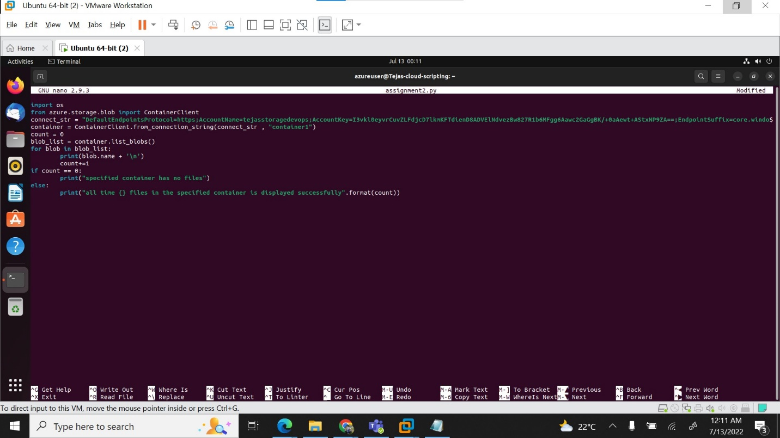

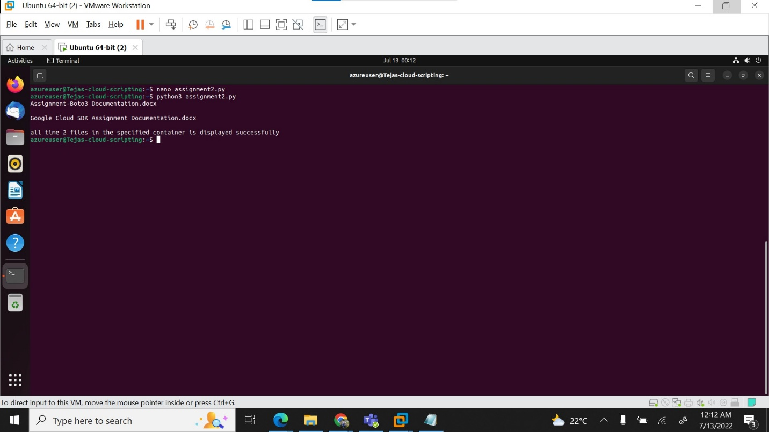

3.Write a script to download files from the container and add '_downloaded' as a prefix to '.txt'. **(1)**

4.Write a script to delete all the files and the container and the storage account that you have created. **(1)**